No Oak Acorns or Sugar Maple Keys to be Found??
No Problem! Try Some Other Native Trees in your Neighbourhood…

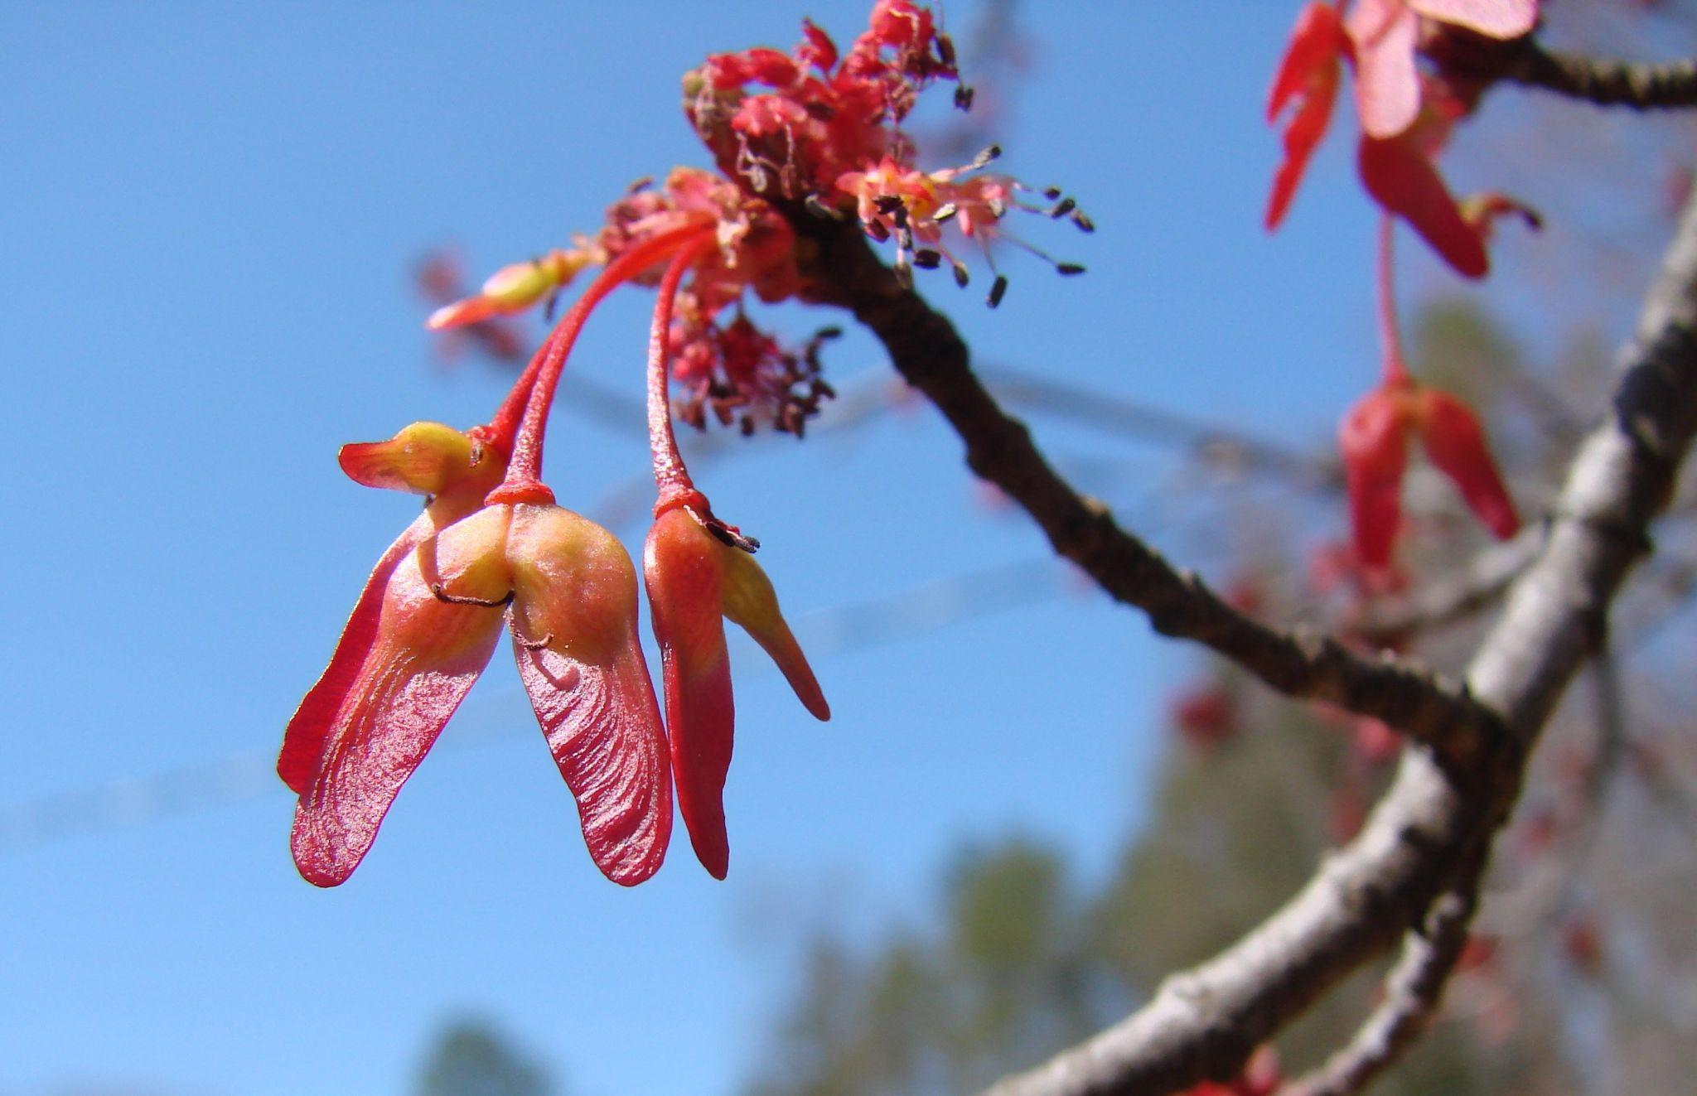
Red maple keys emerge every Spring

Some years during the Fall, it seems we are slipping on Red or White oak acorns everywhere, or sugar maple keys are flying off the trees. In other years, there are none to be found anywhere. What’s going on??

It turns out that some trees do not naturally produce seeds every year - some oaks and maples fit this description. Can you think of 2 reasons why trees might not grow seeds every year?

Just because these trees don’t make seeds each and every year, this is a great opportunity to try your hand at growing some other species!! Give it a try!!

Student Challenge: See if you can grow any 2* of the following species from their seeds before the end of the school year:

*Bonus: A bonus will be given to any additional species of tree grown beyond the basic requirement of 2!

The following native tree species can be found in southern Ontario and they all produce seeds in the Fall:

Butternut Hickory Shagbark Hickory Black Walnut
Eastern White Cedar Paper Birch Tulip tree
Kentucky Coffee tree American Sycamore Eastern Redbud

In the Spring, seeds from both the Red maple and Silver maple can be gathered.

Please click here to get additional information on some of the above species.

To Complete the Challenge:
- In addition to our resources provided, use the Internet to research any 2 of the above species that you would like to grow from seed. A good search engine prompt to use is “How to Grow a (fill in species name) From Seed” - you should get lots of useful advice and pointers from both amateur and professional growers alike. YouTube often has videos that are helpful too!

- Use the information you gather to collect the seeds and grow at least one healthy seedling of each of your 2 desired species before the end of the school year.

- Create an “instructional video” for future students by filming the following steps on your camera/phone. Submit your instructional video to your teacher when complete.

  - identifying the tree that produced the seed in its outdoor location,
  - describing at least 2 interesting facts about your tree,
  - collecting the of seeds from the tree in question,
  - preparing the seeds (this can include the “stratification” and/or “scarification” process,
  - planting the seeds when ready (following correct preparation of the steps above) and the initial growth of the young seedlings.

- Once you have completed your assignment, you can then take the seedlings home, nurture them further and plant them into the ground.

